WMEC111 Unity report

Marks claimed:

Indoor Section – probuilder and primitive (25%)

Outdoor section – trees, waterfall, lake (25%)

Textures on indoor (5%) - normal maps (5%)

Direct light beyond directional (5%) – light probs (5%)

Particle effect (10%) (waterfall)

Object controlled by physics – joint (10%)

Navmesh (5%) - Multiple NavMesh (5%)

Total marks claimed: 100%

Light Probe:  
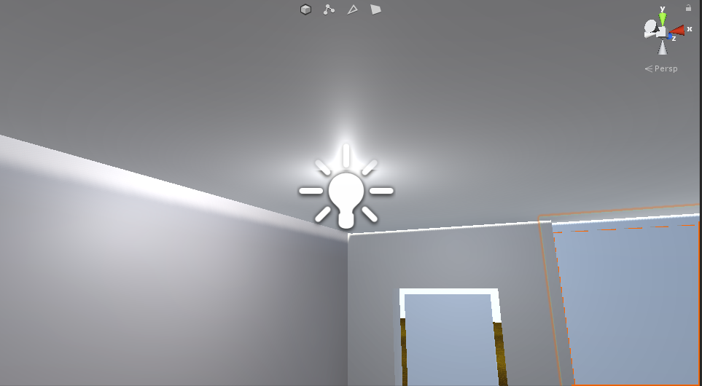

The house has a light on the first floor. The house has textures with normal maps.

Outdoor Terrain

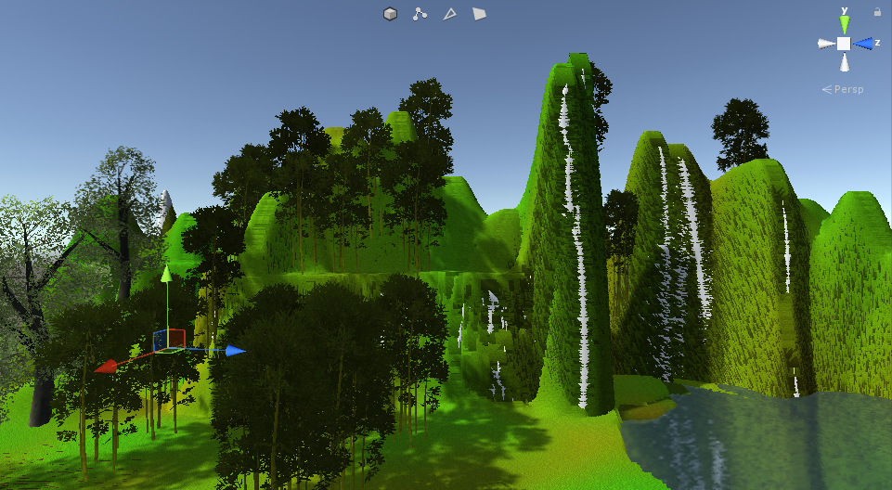

The outdoor terrain includes trees, waterfall and lake.

Patroller

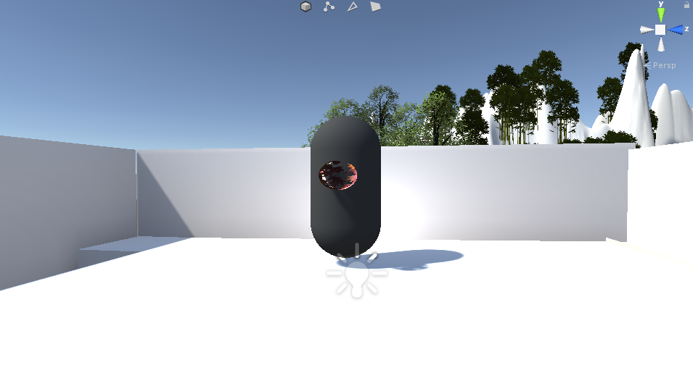

The patroller patrols the top of the house.